**CMSC203 Java Assignments / Projects (example of the project submission)**

**Part1: Documentation Example**

Class: CMSC203 CRN XXXX

 Program: Assignment #

Instructor: Dr. Grinberg

 Summary of Description: (Give a brief description for each Program) A program that requires you to use functions to calculate the volume of a box and the volume of a Sphere.

 Due Date: MM/DD/YYYY (<06/26/2020>)

 Integrity Pledge: I pledge that I have completed the programming assignment independently.

 I have not copied the code from a student or any source.

**Pseudo Code Example:** Here is an example of pseudo code for a program that requires you to use functions to calculate the volume of a box and the volume of a Sphere.

1. Create a scanner to receive input from the keyboard.
2. Declare four variables to store the following information, in decimal form.

* Length
* Width
* Height
* Radius

1. Prompt the user to enter the length, width and height of the box.
2. Receive the input and store the data in the corresponding variables.
3. Prompt the user to enter the radius of the sphere.
4. Receive the input and store the data into the appropriate corresponding variable.
5. Create a function of type double name volumeOfBox() that will take three parameters, for the length width and height of the box. Within this function declare a variable to store the volume of the box and set it equal to the length times the width times the height. Lastly return the volume.
6. Create a function of type double name volumeOfSphere() that will take one parameter, for the radius of the Sphere. Within this function declare two variables, one to store the volume of the sphere and the other to store the constant value of 3.14. next set the variable store the data for volume equal to the formula $\frac{3}{4}πr^{3}$. Lastly return the volume.
7. Inside of the main method declare two variables to store the volume of the box and sphere in decimal format, set those variable equal to their corresponding function calls.
8. Use those variables to display the volume the box and sphere in a message.

**Comprehensive Test Plan**

A good test plan should be comprehensive. This means you should have a few test cases that test when the input is in and out of range, division by 0, incorrect Data type, etc.(Provide valid and invalid input)

|  |  |  |  |  |
| --- | --- | --- | --- | --- |
| Cases | Input | Expected Output | Actual Output | Did Test Pass? |
| Case 1 | Please enter the length width and Height of your box.  Length: 25  Width: 30  Height: 45  Thank you, now enter the radius of your sphere.  Radius: 30 | Thank you, now enter the radius of your sphere.  Radius: 30  The volume of your box is: 33750.0  The volume of your Sphere is: 113040.0 | Thank you, now enter the radius of your sphere.  Radius: 30  The volume of your box is: 33750.0  The volume of your Sphere is: 113040.0 | Y |
| Case 2 | Please enter the length width and Height of your box.  Length: 202.234  Width: 34.56666  Height: 2220.54321  Thank you, now enter the radius of your sphere.  Radius: 456.76543 | The volume of your box is: 1.5522827037730835E7  The volume of your Sphere is: 3.9897718904401493E8 | The volume of your box is: 1.5522827037730835E7  The volume of your Sphere is: 3.9897718904401493E8 | Y |
| Case 3 | Length: five | Expect error message: ”Would you please enter positive numbers” | InputMismatchException | F |
| Case 4 | Please enter the length width and Height of your box.  Length: -25  Width: -25  Height: -25 | Expect error message: ”Would you please enter positive numbers” | Thank you, now enter the radius of your sphere.  Radius: -25  The volume of your box is: -15625.0  The volume of your Sphere is: -65416.666666666664 | F |

**Screenshots for each case listed in the Test Plan**

**Case 1:**

Please enter the length width and Height of your box.

Length: 25

Width: 30

Height: 45

Thank you, now enter the radius of your sphere.

Radius: 30

The volume of your box is: 33750.0

The volume of your Sphere is: 113040.0

**Case 2:**

Please enter the length width and Height of your box.

Length: 202.234

Width: 34.56666

Height: 2220.54321

Thank you, now enter the radius of your sphere.

Radius: 456.76543

The volume of your box is: 1.5522827037730835E7

The volume of your Sphere is: 3.9897718904401493E8

**Case 3:**

Please enter the length width and Height of your box.

Length: five

Exception in thread "main" java.util.InputMismatchException

at java.util.Scanner.throwFor(Scanner.java:864)

at java.util.Scanner.next(Scanner.java:1485)

at java.util.Scanner.nextDouble(Scanner.java:2413)

at cmsc201fall16.Practice.main(Practice.java:21)

C:\Users\grigo\AppData\Local\NetBeans\Cache\8.1\executor-snippets\run.xml:53: Java returned: 1

BUILD FAILED (total time: 4 seconds)

**Case 4:**

Please enter the length width and Height of your box.

Length: -25

Width: -25

Height: -25

Thank you, now enter the radius of your sphere.

Radius: -25

The volume of your box is: -15625.0

The volume of your Sphere is: -65416.666666666664

**Lessons Learned:**

Write about your Learning Experience, highlighting your lessons learned and learning experience from working on this project.

What have you learned?

What did you struggle with?

What would you do differently on your next project?

What parts of this assignment were you successful with, and what parts (if any) were you not successful with?

Provide any additional resources/links/videos you used to while working on this assignment/project.

<Provide answers to the questions listed above>

**Check List:**

|  |  |  |  |
| --- | --- | --- | --- |
| **#** |  | **Y/N** | **Comments** |
|  | **Assignment files:** |  |  |
|  | * FirstInitialLastName_ Assignment#_Moss.zip | **Yes or No** |  |
|  | * FirstInitialLastName_Assignment#.docx/.pdf | **Yes or No** |  |
|  | * Source java files | **Yes or No** |  |
|  | **Program compiles** | **Yes or No** |  |
|  | **Program runs with desired outputs related to a Test Plan** | **Yes or No** |  |
|  | **Documentation file:** |  |  |
|  | * Comprehensive Test Plan | **Yes or No** |  |
|  | * Screenshots for each Test case listed in the Test Plan | **Yes or No** |  |
|  | * Screenshots of your GitHub account with submitted Assignment# (if required) | **Yes or No or N/A** |  |
|  | * UML Diagram (if required) | **Yes or No or N/A** |  |
|  | * Algorithms/Pseudocode (if required) | **Yes or No or N/A** |  |
|  | * Flowchart (if required) | **Yes or No or N/A** |  |
|  | * Lessons Learned | **Yes or No** |  |
|  | * Checklist is completed and included in the Documentation | **Yes or No** |  |

**Flow Chart Shapes:**

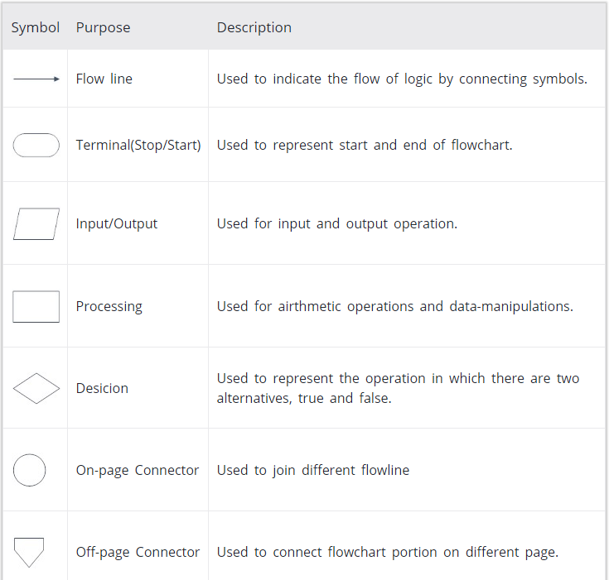

**Flowchart Example (If required):**

**Draw a flowchart to add two numbers entered by the user.**

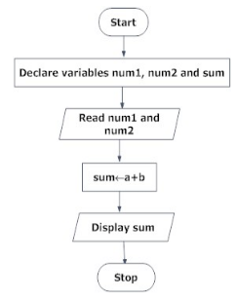

**UML Class Diagram Example (If required):** If you have a class named person with the attributes of name, age and weight, and methods one of type String named getName() and one of type void named setName(), here is what the UML should look like.

|  |
| --- |
| **Class Name:**  **Practice** |
| **+name:String**  **+age:int**  **+weight:double** |
| **+getName():String**  **+setName(name:String):void** |

**Part2: Example how your source code should look: Source Code Practice.java (not part of the document file. All java files submitted separately as part of the assignment submission box)**

/**

 * Class: CMSC203

 * Program: Assignment #

* Instructor: Dr. Grinberg

 * Description: (Give a brief description for each Program)

A program that requires you to use functions to calculate the volume of a box and the volume of a Sphere.

 * Due: MM/DD/YYYY (<03/26/2020>)

 * I pledge that I have completed the programming assignment independently.

   I have not copied the code from a student or any source.

   I have not given my code to any student.

   Print your Name here: __________

*/

**public** **class** Practice {

**public** **static** **void** main(String[] args) {

Scanner input = **new** Scanner(System.***in***);

**double** l, w, h, r;

//Prompt the user to enter the dimensions for the box.

System.***out***.println("Please enter the length width and Height of your box.");

System.***out***.print("Length: ");

l = input.nextDouble();

System.***out***.print("Width: ");

w = input.nextDouble();

System.***out***.print("Height: ");

h = input.nextDouble();

//Prompt the user to enter the radius of the sphere.

System.***out***.println("Thank you, now enter the radius of your spere.");

System.***out***.print("Radius: ");

r = input.nextDouble();

**double** boxVolume = *volumeOfBox*(l, w, h);

**double** sphereVolume = *volumeOfSpere*(r);

System.***out***.println("The volume of your box is: " + boxVolume);

System.***out***.println("The volume of your Sphere is: " + sphereVolume);

}

/**

* Function: volumeOfBox (double, double, double);

* Description: Function used to calculate the volume of any box.

* Pre: The length, width, and height of the box.

* Post: The function will return the volume of the box

*/

**public** **static** **double** volumeOfBox(**double** length, **double** width, **double** height){

**double** volume = length*width*height;

**return** volume;

}

/**

* Function: volumeOfSphere (double, double, double);

* Description: Function use the calculate the volume of any sphere.

* Pre: The radius of sphere.

* Post: The function will return the volume of the sphere

*/

**public** **static** **double** volumeOfSphere(**double** radius){

**final** **double** PI = 3.14;

**double** volume = (4.0/3.0)*PI*(Math.*pow*(radius, 3));

**return** volume;

}

}

**Notes:**

* Proper naming conventions: All constants, except 0 and 1, should be named. Constant names should be all upper-case, variable names should begin in lower case, but subsequent words should be in title case. Variable and method names should be descriptive of the role of the variable or method. Single letter names should be avoided.
* Documentation: The documentation requirement for all programming projects is one block comment at the top of the program containing the course name, the project number, your name, the date and platform/compiler that you used to develop the project. If you use any code or specific algorithms that you did not create, a reference to its source should be made in the appropriate comment block. Additional comments should be provided as necessary to clarify the program.

Indentation: It must be consistent throughout the program and must reflect the control structure